EARTH’S GREATEST ENEMY
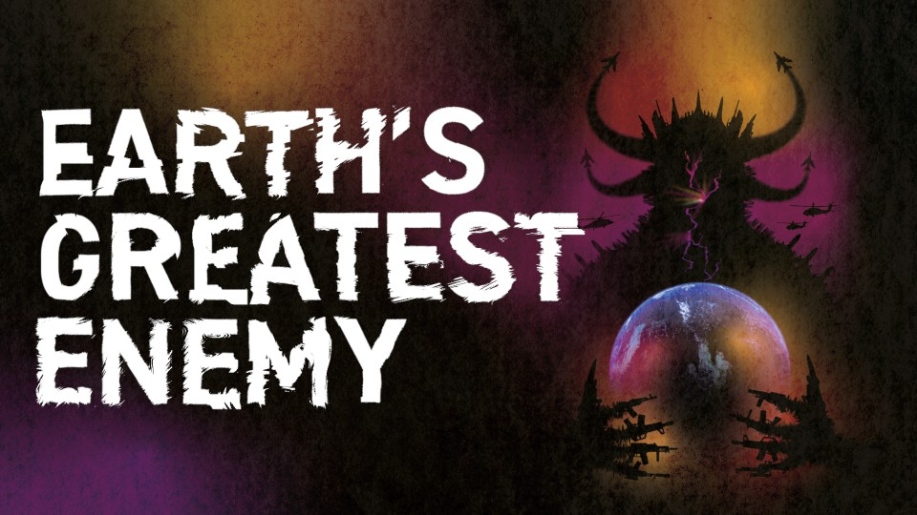
THE ENVIRONMENTAL COST OF HISTORY’S BIGGEST MILITARY

Logline
A foreign policy reporter and her Iraq veteran husband turn their sights on the
hidden impact the US military has on the planet, after the birth of their first child creates anxiety about the climate crisis. Their investigation exposes a secretive and constantly- expanding web of pollution, cover-ups and unaccountability by the world's biggest polluter.

Short Synopsis
Earth’s Greatest Enemy reveals a hidden truth rarely questioned in mainstream reporting: the role of the U.S. military as the world’s largest institutional polluter, tracing the link between war, empire, and ecological destruction. Drawing on powerful testimonies from veterans, scientists, and frontline communities, it uncovers how military operations poison ecosystems, accelerate global warming, and sacrifice the future for endless expansion. From Alaska’s melting glaciers to contaminated bases across the U.S. and
toxic battlefields abroad, Earth’s Greatest Enemy delivers a provocative and unflinching examination of the untouchable institution playing an outsized role in the climate crisis.

Key Credits
Director: Abby Martin Producer/Writer: Mike Prysner

Notable Previous Work

Gaza Fights for Freedom (2019) — Prescient in its focus on Palestine before it entered mainstream discourse, the film became a
go-to resource for millions and continues to be screened worldwide by activists and organizers.

About the Filmmakers
Abby Martin is a renowned journalist and documentarian, known for her uncompromising independence and on-the- ground reporting from conflict zones. She is the creator of the acclaimed series The Empire Files.

Mike Prysner is an Iraq War veteran turned prominent anti-war activist and writer. A
co-creator of The Empire Files, his sharp critiques of U.S. militarism have reached millions, and he brings firsthand experience to this investigation.

theempireiles@gmail.com | earthsgreatestenemy.com | socials: @empireiles

